It is also possible to handle the more complex case of refraction through multiple layers. Each layer can be rendered with the depths and normals stored in textures. A procedure in the spirit of relief mapping (Section 6.8.1) can then be used to trace rays through the layers. Stored depths are treated as a heightfield that each ray walks until an intersection is found. Oliveira and Brauwers [1326] present such a framework to handle refraction through backfaces of meshes. Furthermore, nearby opaque objects can be converted into color and depth maps, providing a last opaque layer [1927]. A limitation of all these image-space refraction schemes is that what is outside of the screen’s boundaries cannot refract or be refracted.

## 14.5.3 Caustics and Shadows

Evaluating shadows and caustics resulting from refracted and attenuated light is a complex task. In a non-real-time context, multiple methods, such as bidirectional path tracing or photon mapping [822, 1413], are available to achieve this goal. Luckily, many methods offer approximations of such phenomenon in real time.

*Caustics* are the visual result of light being diverged from its straight path, for instance by a glass or water surface. The result is that the light will be defocused from some areas, creating shadows, and focused in some others, where ray paths become more dense, resulting in stronger incident lighting. Such paths depend on the curved surface that the light encounters. A classic example for reflection is the cardioid caustic seen inside a coffee mug. Refractive caustics are more noticeable, e.g., light focused through a crystal ornament, a lens, or a glass of water. See Figure 14.39. Caustics can also be created due to light being reflected and refracted by a curved water surface, both above and below. When converging, light will concentrate on opaque surfaces and generate caustics. When under the water surface, converging light paths

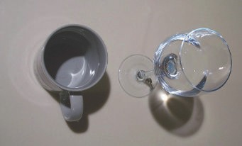

Figure 14.39. Real-world caustics from reﬂection and refraction.

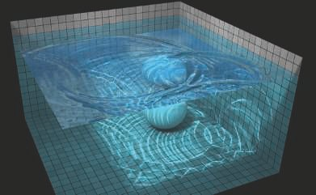

Figure 14.40. Demo of caustic eﬀects in water. *(Image from WebGL Water demo courtesy of Evan Wallace [1**831**].)*

will become visible within the water volume. This will result in well-known light shafts from photons scattering through water particles. Caustics are a separate factor beyond the light reduction coming from Fresnel interaction at the volume’s boundary and the transmittance when traveling through it.

In order to generate caustics from water surfaces, one may apply an animated texture of caustics generated offline as a light map applied on a surface, potentially added on top of the usual light map. Many games have taken advantage of such an approach, such as *Crysis 3* running on CryEngine [1591]. Water areas in a level are authored using *water volumes*. The top surface of the volume can be animated using a bump map texture animation or a physical simulation. The normal resulting from the bump map can be used, when vertically projected above and under the water surface, to generate caustics from their orientation mapped to a radiance contribution. Distance attenuation is controlled using an artist-authored height-based maximum influence distance. The water surface can also be simulated, reacting to object motion in the world and thus generating caustic events matching what is occurring in the environment. An example is shown in Figure 14.40.

When underwater, the same animated water surface can also be used for caustics within the water medium. Lanza [977] propose a two-step method to generate light shafts. First, light positions and refraction directions are rendered from the light’s point of view and saved into a texture. Lines can then be rasterized starting from the water surface and extending in the refraction direction in the view. They are accumulated with additive blending, and a final post-process blur can be used to blur out the result in order to mask the low number of lines.

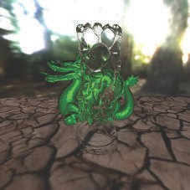 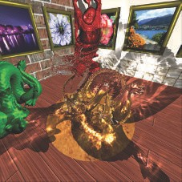

Figure 14.41. On the left, the Buddha refracts both nearby objects and the surrounding skybox [1927]. On the right, caustics are generated via hierarchical maps similar in nature to shadow maps [1929]. *(Images courtesy of Chris Wyman, University of Iowa.)*

Wyman [1928, 1929] presents an image-space technique for caustic rendering. It works by first evaluating photon positions and incident directions after refraction through transparent objects’ front- and backfaces. This is achieved by using the background refraction technique [1927] presented in Section 14.5.2. However, instead of storing refracted radiance, textures are used to store the scene intersection position, post-refraction incident direction, and transmittance due to the Fresnel effect. Each texel stores a photon that can then be splatted with the correct intensity back into the view. To achieve this goal there are two possibilities: Splat photons as quads in view space or in light space, with Gaussian attenuation. One result is shown in Figure 14.41. McGuire and Mara [1185] proposed a simpler approach to caustic- like shadows by varying transmittance based on the transparent surface’s normal, transmitting more if perpendicular to the incident surface and less otherwise, due to the Fresnel effect. Other volumetric shadow techniques are described in Section 7.8.

# Subsurface Scattering

Subsurface scattering is a complex phenomenon found in solid materials having high scattering coefficients (see Section 9.1.4 for more details). Such materials include wax, human skin, and milk, as seen in Figure 14.2 on page 592.

General light scattering theory has been explained in Section 14.1. In some cases, the scale of scattering is relatively small, as for media with a high optical depth, such as human skin. Scattered light is re-emitted from the surface close to its original point of entry. This shift in location means that subsurface scattering cannot be modeled

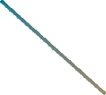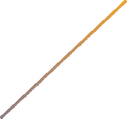

Figure 14.42. Light scattering through an object. Initially the light transmitted into the object travels in the refraction direction, but scattering causes it to change direction repeatedly until it leaves the material. The length of each path through the material determines the percentage of light lost to absorption.

with a BRDF (Section 9.9). That is, when the scattering occurs over a distance larger than a pixel, its more global nature is apparent. Special methods must be used to render such effects.

Figure 14.42 shows light being scattered through an object. Scattering causes in- coming light to take many different paths. Since it is impractical to simulate each photon separately (even for offline rendering), the problem must be solved proba- bilistically, by integrating over possible paths or by approximating such an integral. Besides scattering, light traveling through the material also undergoes absorption.

One important factor that distinguishes the various light paths shown in Fig- ure 14.42 is the number of scattering events. For some paths, the light leaves the ma- terial after being scattered once; for others, the light is scattered twice, three times, or more. Scattering paths are commonly grouped as *single scattering* and *multiple scattering*. Different rendering techniques are often used for each group. For some materials, single scattering is a relatively weak part of the total effect, and multiple scattering predominates, e.g., skin. For these reasons, many subsurface scattering ren- dering techniques focus on simulating multiple scattering. In this section we present several techniques to approximate subsurface scattering.

## Wrap Lighting

Perhaps the simplest of the subsurface scattering methods is *wrap lighting* [193]. This technique was discussed on page 382 as an approximation of area light sources. When used to approximate subsurface scattering, we can add a color shift [586]. This ac- counts for the partial absorption of light traveling through the material. For example, when rendering skin, a red color shift could be applied.

When used in this way, wrap lighting attempts to model the effect of multiple scattering on the shading of curved surfaces. The “leakage” of light from adjacent points into the currently shaded point softens the transition area from light to dark where the surface curves away from the light source. Kolchin [922] points out that this effect depends on surface curvature, and he derives a physically based version. Although the derived expression is somewhat expensive to evaluate, the ideas behind it are useful.

## Normal Blurring

Stam [1686] points out that multiple scattering can be modeled as a *diffusion* process. Jensen et al. [823] further develop this idea to derive an analytical *bidirectional surface scattering distribution function* (BSSRDF) model. The BSSRDF is a generalization of the BRDF for the case of global subsurface scattering [1277]. The diffusion process has a spatial blurring effect on the outgoing radiance.

This blurring is applied to only the diffuse reflectance. Specular reflectance occurs at the material surface and is unaffected by subsurface scattering. Since normal maps often encode small-scale variation, a useful trick for subsurface scattering is to apply normal maps to only the specular reflectance [569]. The smooth, unperturbed normal is used for the diffuse reflectance. Since there is no added cost, it is often worthwhile to apply this technique when using other subsurface scattering methods.

For many materials, multiple scattering occurs over a relatively small distance. Skin is an important example, where most scattering takes place over a distance of a few millimeters. For such materials, the technique of not perturbing the diffuse shad- ing normal may be sufficient by itself. Ma et al. [1095] extend this method, based on measured data. They determined the reflected light from scattering objects and found that, while the specular reflectance is based on the geometric surface normals, subsur- face scattering makes diffuse reflectance behave as if it uses blurred surface normals. Furthermore, the amount of blurring can vary over the visible spectrum. They pro- pose a real-time shading technique using independently acquired normal maps for the specular reflectance and for the R, G, and B channels of the diffuse reflectance [245]. Using different normal maps for each channel will then result in color bleeding. Since these diffuse normal maps typically resemble blurred versions of the specular map, it is straightforward to modify this technique to use a single normal map, while adjusting the mipmap level, but at the cost of losing the color shift since the normal is the same for each channel.

## Pre-Integrated Skin Shading

Combining the idea of wrap lighting and normal blurring, Penner [1369] proposes a pre-integrated skin shading solution.

Scattering and transmittance are integrated and stored in a two-dimensional lookup table. The LUT’s first axis is indexed based on n · l. The second axis is

indexed based on 1*/r* = *∂n/∂p* , representing the surface curvature. The higher the curvature, the greater the impact on the transmitted and scattered color. Because curvature is constant per triangle, these values must be baked and smoothed offline. To handle the effect of subsurface scattering on small surface details, Penner mod- ifies the technique by Ma et al. [1095], which was discussed in the previous section. Instead of acquiring separate normal maps for the R, G, and B diffuse reflectance, Penner generates them by blurring the original normal map according to the diffusion profile of the subsurface material for each color channel. Since using four separate nor- mal maps is memory intensive, as an optimization he uses a single smoothed normal

|| ||

map that is blended with the vertex normal for each color channel.

This technique will ignore light diffusion across shadow boundaries, since by default it only relies on curvature. To get the scattering profile to span through shadow boundaries, the shadow penumbra profile can be used to bias the LUT coordinates. Thus, this fast technique is able to approximate the high-quality method presented in the next section [345].

## Texture-Space Diffusion

Blurring the diffuse normals accounts for some visual effects of multiple scattering, but not for others, such as softened shadow edges. The concept of *texture-space diffusion* can be used to address these limitations. This idea was introduced by Lensch et al. [1032] as part of a different technique, but the version presented by Borshukov and Lewis [178, 179] has been the most influential. They formalize the idea of multiple scattering as a blurring process. First, the surface irradiance (diffuse lighting) is rendered into a texture. This is done by using texture coordinates as positions for rasterization. The real positions are interpolated separately for use in shading. This texture is blurred and then used for diffuse shading when rendering. The shape and size of the filter depends on the material and on the wavelength. For example, for skin, the R channel is filtered with a wider filter than G or B, causing reddening near shadow edges. The correct filter for simulating subsurface scattering in most materials has a narrow spike in the center and a wide, shallow base. This technique was first presented for use in offline rendering, but real-time GPU implementations were soon proposed by researchers at NVIDIA [345, 586] and ATI [568, 569, 803, 1541].

The presentation by d’Eon and Luebke [345] represents one of the most complete treatments of this technique, including support for complex filters mimicking the effect of multi-layer subsurface structure. Donner and Jensen [369] show that such structures produce the most realistic skin renderings. The full NVIDIA skin rendering system presented by d’Eon and Luebke produces excellent results (see Figure 14.43 for an example), but is quite expensive, requiring a large number of blurring passes. However, it can easily be scaled back to increase performance.

Instead of applying multiple Gaussian passes, Hable [631] presents a single 12- sample kernel. The filter can be applied either in texture space as a preprocess or in the pixel shader when rasterizing the mesh on screen. This makes face rendering much



**X X X X X X**

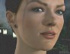

**+**

Figure 14.43. Texture-space multi-layer diﬀusion. Six diﬀerent blurs are combined using RGB weights. The ﬁnal image is the result of this linear combination, plus a specular term. *(Images courtesy of NVIDIA Corporation [3**45**].)*

faster at the cost of some realism. When close up, the low amount of sampling can become visible as bands of color. However, from a moderate distance, the difference in quality is not noticeable.

## Screen-Space Diffusion

Rendering a light map and blurring it for all the meshes in a scene can quickly become expensive, both computationally and memory-wise. Furthermore, the meshes need to be rendered twice, once in the light map and once in the view, and the light map needs to have a reasonable resolution to be able to represent subsurface scattering from small-scale details.

To counter these issues, Jimenez proposed a screen-space approach [831]. First, the scene is rendered as usual and meshes requiring subsurface scattering, e.g., human faces, will be noted in the stencil buffer. Then a two-pass screen-space process is ap- plied on the stored radiance to simulate subsurface scattering, using the stencil test to apply the expensive algorithm only where it is needed, in pixels containing translucent material. The additional passes apply the two one-dimensional and bilateral blur ker- nels, horizontally and vertically. The colored blur kernel is separable, but it cannot be applied in a fully separable fashion for two reasons. First, linear view depth must be taken into account to stretch the blur to a correct width, according to surface distance. Second, bilateral filtering avoids light leaking from materials at different depths, i.e., between surfaces that should not interact. In addition, the normal orientation must be taken into account for the blur filter to be applied not only in screen space but tangentially to the surface. In the end, this makes the separability of the blur kernel an approximation, but still a high-quality one. Later, an improved separable filter

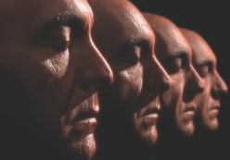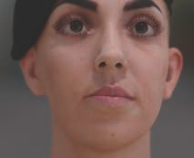

Figure 14.44. High-quality render of scanned model faces. Screen-space subsurface scattering makes it possible to render realistic human skin material on many characters with a single post-process. *(Left image: render courtesy of Jorge Jimenez and Diego Gutierrez, Universidad de Zaragoza. Scan cour- tesy of XYZRGB Inc. Right image: render courtesy of Jorge Jimenez et al., Activision Publishing, Inc., 2013 and Universidad de Zaragoza. Scan courtesy of Lee Perry-Smith, Infinite-Realities [8**31**].)*

was proposed [833]. Being dependent on the material area on screen, this algorithm is expensive for close-ups on faces. However, this cost is justifiable, since high quality in these areas is just what is desired. This algorithm is especially valuable when a scene is composed of many characters, since they will all be processed at the same time. See Figure 14.44.

To further optimize the process, the linear depth can be stored in the alpha channel of the scene texture. The one-dimensional blur relies on a low number of samples, so undersampling can be visible on faces close up. To avoid this issue, the kernel can be rotated per pixel, which will hide ghosting artifacts with noise [833]. The visibility of this noise can be significantly reduced by using temporal antialiasing (Section 5.4.2). When implementing screen-space diffusion, care must be taken to blur only irradi- ance and not the diffuse albedo or specular lighting. One way to achieve this goal is to render irradiance and specular lighting into separate screen-space buffers. If deferred shading (Section 20.1) is used, then a buffer with diffuse albedo is already available. To reduce memory bandwidth, Gallagher and Mittring [512] propose storing irradi- ance and specular lighting in a single buffer, using a checkerboard pattern. After the irradiance has been blurred, the final image is composited by multiplying the diffuse

albedo with the blurred irradiance and adding the specular lighting on top.

Within this screen-space framework, it is also possible to render large-scale subsur- face scattering phenomena, such as the light traveling through the nose or ears. When rendering the mesh diffuse lighting, the technique presented by Jimenez et al. [827] also adds the subsurface transmission from backface contributions by sampling the incoming light from the opposite side using the negated surface normal n. The re- sult is modulated by a transmittance value estimated using the depth recovered by sampling a traditional shadow map rendered from the light’s point of view, similarly

−

to the method by Dachsbacher and Stamminger [320] described in the next section. To represent forward scattering in a cone, the shadow map can be sampled multiple times. In order to use a low sample count per pixel to reduce the cost of rendering, it is possible to take two shadow samples with a randomized offset or rotation per pixel. Doing so will result in much unwanted visual noise. Thankfully, this noise can auto- matically be filtered out for free by the screen-space subsurface blur kernel required to achieve the translucent subsurface light diffusion. It is thus possible to render high- quality translucency effects simulating forward light scattering in a cone through the thin parts of a face with only one extra depth-map sample per light source.

## Depth-Map Techniques

The techniques discussed so far model light scattering over relatively small distances, e.g., skin. Other techniques are needed for materials exhibiting large-scale scattering, such as light traveling through a hand. Many of these focus on single scattering, which is easier to model than multiple scattering.

The ideal simulation for large-scale single scattering can be seen on the left in Figure 14.45. The light paths change direction on entering and exiting the object, due to refraction. The effects of all the paths need to be summed to shade a single surface point. Absorption also needs to be taken into account—the amount of absorption in a path depends on its length inside the material. Computing all these refracted rays for a single shaded point is expensive even for offline renderers, so the refraction on entering the material is usually ignored, and only the change in direction on exiting the material is taken into account [823]. Since the rays cast are always in the direction of the light, Hery [729, 730] points out that light-space depth maps, typically used for shadowing, can be accessed instead of performing ray casting. See the middle of Figure 14.45. For media that scatter light according to a phase function, the scattering angle also affects the amount of scattered light.

Performing depth-map lookups is faster than ray casting, but the multiple sam- ples required makes Hery’s method too slow for most real-time rendering applications. Green [586] proposes a faster approximation, shown on the right in Figure 14.45. Al- though this method is less physically based, its results can be convincing. One problem is that details on the back side of the object can show through, since every change in object thickness will directly affect the shaded color. Despite this, Green’s approxima- tion is effective enough to be used by Pixar for films such as *Ratatouille* [609]. Pixar refers to this technique as *gummi lights*. Another problem with Hery’s implementa- tion is that the depth map should not contain multiple objects, or highly non-convex objects. This is because it is assumed that the entire path between the shaded (blue) point and the intersection (red) point lies within the object. Pixar gets around this problem by using a type of deep shadow map [1066].

Modeling large-scale multiple scattering in real time is quite difficult, since each surface point can be influenced by light coming from any other surface point. Dachs- bacher and Stamminger [320] propose an extension of shadow mapping, called *translu-*

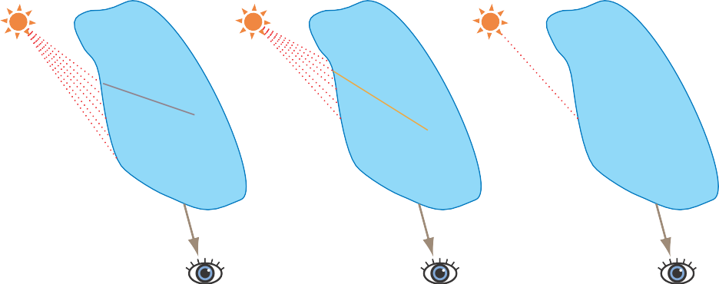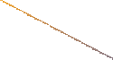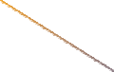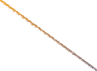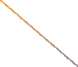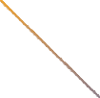

Figure 14.45. On the left, the ideal situation, in which light refracts when entering and exiting the object; all scattering contributions that would properly refract upon leaving the object are correctly gathered via ray marching within the material. The length of each path will be accounted for when evaluating extinction *σ*t. This is achievable using path tracing or a few real-time approximations [320]. The middle image shows a computationally simpler situation, in which the rays refract only on exit. This is the usual approximation done in real-time rendering because ﬁnding the entry points (in red) from sample points (in yellow) with respect to refraction is not straightforward. The right image shows an approximation, which is therefore faster, where only a single ray is considered instead of multiple samples along the refracted ray [586].

*cent shadow mapping*, for modeling multiple scattering. Additional information, such as irradiance and the surface normal, is stored in light-space textures. Several sam- ples are taken from these textures, including the depth map, and combined to form an estimation of the scattered radiance. A modification of this technique is used in NVIDIA’s skin rendering system [345]. Mertens et al. [1201] propose a similar method, but use a texture in screen space rather than light space.

Leaves in trees also exhibit a strong subsurface scattering effect, appearing as a bright green color when light is coming in from behind. In addition to the albedo and normal textures, a texture representing transmittance *Tr* through the leaf volume can be mapped onto the surface [1676]. Then, an ad hoc model can be used to approximate the additional subsurface contribution from lights. Since leaves are thin elements, a negated normal can be used as an approximation to the opposite side normal n. The backlit contribution can be evaluated as (l n)+ ( v l)+, where l is the light direction and v is the view direction. It can then be multiplied with the surface albedo and added on top of the direct light contributions.

·− · − ·

In a similar fashion, Barr´e-Brisebois and Bouchard [105] present an inexpensive ad hoc approximation to large-scale subsurface scattering on meshes. First, for each mesh they generate a grayscale texture storing an *averaged local thickness*, which is one minus the ambient occlusion computed from the inward-facing normal −n. This texture, called *t*ss, is considered an approximation to the transmittance that can be applied to light coming from the opposite side of the surface. The subsurface scattering

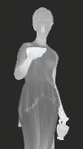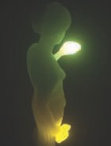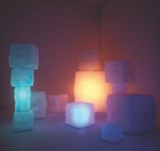

Figure 14.46. On the left, a local thickness texture generated for a statue of Hebe. In the middle, the subsurface light scattering eﬀect that can be achieved with it. On the right, another scene with translucent cubes rendered using the same technique. *(Images courtesy of Colin Barr´e-Brisebois and Marc Bouchard [1**05**].)*

added to the regular surface lighting is evaluated as

*t* c .(v · −l)+Σ*p,* (14.30)

ss ss

where l and v are the normalized light and view vectors, respectively, *p* is an exponent approximating a phase function (as shown in Figure 14.10 on page 599), and css is the subsurface albedo. This expression is then multiplied with the light color, intensity, and distance attenuation. This model is not physically based or energy conserving, but it is able to rapidly render plausible subsurface lighting effects in a single pass. See Figure 14.46.

# Hair and Fur

Hairs are protein filaments that grow out of the dermis layer of mammals. In the case of humans, hair is scattered in different areas of the body, and different types include top-of-head, beard, eyebrows, and eyelashes. Other mammals are often covered with fur (dense, limited-length hair), and fur’s properties tend to vary in different locations on an animal’s body. Hairs can be straight, wavy, or curly, each with a different strength and roughness. Hair strands can naturally be black, brown, red, blond, gray, or white, and can be dyed (with varying success) all the colors of the rainbow.

Hair and fur structure is fundamentally the same. It consists of three layers [1052, 1128], as shown in Figure 14.47:

Outside is the cuticle, which represents the surface of the fiber. This surface is not smooth but is composed of overlapping scales tilted by approximately *α* = 3◦ compared to the hair’s direction, which tilts the normal toward the root.

•

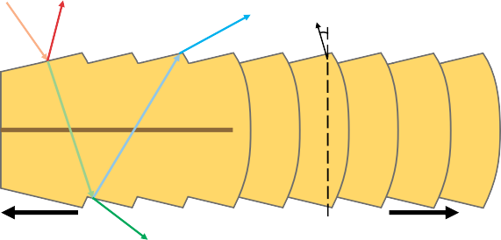

**ωi**

R

TRT

≈3°

cuticle scales

medulla

cortex

root

TT

tip

Figure 14.47. Longitudinal cut of a hair strand presenting the diﬀerent materials composing it, along with lighting components resulting from incoming light along direction *ω*i.

* In the middle is the cortex, containing melanin that gives the fiber its color [346]. One such pigment is eumelanin, responsible for brown color with *σa,e* = (0*.*419*,* 0*.*697*,* 1*.*37), and another is pheomelanin, responsible for red hair with *σa,p* = (0*.*187*,* 0*.*4*,* 1*.*05).

The inner part is the medulla. It is small and often ignored when modeling human hair [1128]. However, it takes up a larger portion of the hair volume for animal fur, where it has greater significance [1052].

•

It is possible to see hair fibers as analogous to particles, as discretization of a vol- ume, but with curves instead of points. Hair fiber lighting interaction is described using a *bidirectional scattering distribution function* (BSDF). This corresponds to a BRDF but with light integrated over a sphere, instead of just a hemisphere. A BSDF aggregates all the interactions happening within hair fibers through the different layers. It is described in detail in Section 14.7.2. Light scatters within fibers but also bounces off many of them, resulting in complex colored radiance from multiple-scattering phe- nomena. Furthermore, because fibers absorb light as a function of their material and pigments, it is also important to represent volumetric self-shadows that occur within the hair volume. In this section we describe how recent techniques allow us to render short hairs, such as beard hair, head hair, and, finally, fur.

## Geometry and Alpha

Hair strands can be rendered as extruded *hair quads* using vertex shader code around hair guide curves painted by an artist, producing a ribbon of quads following the guides. Each quad ribbon follows its matching hair guide curve according to a specified orientation following the skin and representing a clump of hair [863, 1228, 1560]. This approach is well suited for beard or short and mostly static hairs. It is also efficient, because large quads can result in more visual coverage, and thus less ribbons will be needed to cover a head, which in turn improves performance. If more detail is needed, for instance in the case of thin, long hair animated by a physical simulation, it is

possible to use thinner quad ribbons and render thousands of them. In this case, it is better to also orient the generated quads toward the view using a cylinder constraint along the hair curve tangent [36]. Even if a hair simulation is done with just a few hair guides, new strands can be instantiated by interpolating the properties of surrounding hair guides [1954].

All these elements can be rendered as alpha-blended geometry. If used, the ren- dering order of head hairs will need to be correct to avoid transparency artifacts (Section 5.5). To mitigate this issue, it is possible to use a pre-sorted index buffer, ren- dering hair strands close to the head first and outer ones last. This work well for short and non-animated hair but not for long interleaved and animated hair strands. Fixing ordering issues by relying on the depth test is possible using alpha testing. However, this can lead to serious aliasing problems for high-frequency geometry and textures. It is possible to use MSAA with alpha testing being done per sample [1228], at the cost of extra samples and memory bandwidth. Alternately, any order-independent trans- parency method can be used, such as the ones discussed in Section 5.5. For example, TressFX [36] stores the *k* = 8 closest fragments, updated in the pixel shader to keep only the first seven layers ordered, so achieving multi-layer alpha blending [1532].

Another issue is alpha-testing artifacts resulting from mipmapped alpha minifi- cation (Section 6.6). Two solutions to this problem are to perform smarter alpha mipmap generation or to use a more advanced hashed alpha test [1933]. When ren- dering thin long hair strands, it is also possible to modify the hair opacity according to its pixel coverage [36].

Small-scale hairs such as beards, eyelashes, and eyebrows are simpler to render than a head’s full volume of hair. Eyelashes and eyebrows can even be geometry skinned to match head and eyelid movements. The hair surface on these small elements can be lit using an opaque BRDF material. It is also possible to shade hair strands by using a BSDF, as presented in the next section.

## Hair

Kajiya and Kay [847] developed a BRDF model to render volumes consisting of orga- nized and infinitely small cylinder fibers. This model, discussed in Section 9.10.3, was first developed to render furry elements by ray marching through a volume texture representing density above a surface. The BRDF is used to represent the specular and diffuse light response with the volume, and can also be used on hairs.

The seminal work from Marschner et al. [1128] measures light scattering in human hair fibers and presents a model based on these observations. Different components of scattering in a single hair strand have been observed. These are all depicted in Figure 14.47. First, an R component represents reflection of light at the air/fiber interface on the cuticle, which results in a shifted white specular peak toward the root. Second, the TT component represents light traveling through the hair fiber by being transmitted once from air to hair material, and a second time from hair to air. Finally, a third TRT component represents light traveling in the hair fiber by

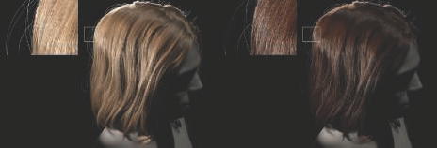

Figure 14.48. Path-traced reference of blond (left) and brown (right) hairs rendered with specular glints resulting from ﬁber eccentricity. *(Image courtesy of d’Eon et al. [3**46**].)*

being transmitted, reflected by the opposite side of the fiber, and then transmitted back outside the hair material. The “R” in the variable name represents one internal reflection. The TRT component is perceived as a secondary specular highlight, shifted compared to R, and is colored since light has been absorbed while traveling through the fiber material.

Visually, the R component is perceived as a colorless specular reflection on the hair. The TT component is perceived as a bright highlight when a volume of hair is lit from behind. The TRT component is crucial to rendering realistic hairs since it will result in glints on strands with eccentricity, i.e., in real-life, a hair’s cross section is not a perfect circle but rather an oval. Glints are important for believability, as these keep hairs from looking uniform. See Figure 14.48.

Marschner et al. [1128] propose functions modeling the R, TT, and TRT compo- nents as part of the hair BSDF that represents the response of a hair fiber to light. The model properly takes into account the Fresnel effect at transmission and reflection events but ignores the other more-involved light paths such as TRRT, TRRRT, and longer.

This original model is, however, not energy conserving. This has been studied and fixed in the work of d’Eon et al. [346]. The BSDF components have been reformu- lated and made energy conserving by better taking into account roughness and the contraction of specular cones. The components have also been extended to include longer paths such as TR*T. Transmittance is also controlled using measured melanin extinction coefficients. Similarly to the work by Marschner et al. [1128], their model is able to faithfully render glints on strands with eccentricity. Another energy-conserving model is presented by Chiang et al. [262]. This model gives a parameterization for roughness and multiple scattering color that is more intuitive to author by artists, instead of having them tweak Gaussian variance or melanin concentration coefficients. Artists may want to author a particular look for the specular term on hair on a character, by changing the roughness parameter, for example. With a physically based energy-conserving and energy-preserving model, the scattered light deep within the

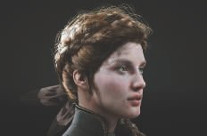

R

TRT

Complete model

TT

Multi

Figure 14.49. Real-time hair rendering with the R, TT, and TRT, as well as a multiple scattering component. *(Image courtesy of Epic Games, Inc. [8**63**,* *1802**].)*

hair volume will also change. To give more artistic control, it is possible to separate the first few scattering paths (R, TT, TRT) and the multiple scattering parts [1525]. This is achieved by maintaining a second set of BSDF parameters, used only for the multiple scattering paths. In addition, the BSDF R, TT, and TRT components can then be represented with simple mathematical shapes that can be understood and tweaked by artists to further refine the look. The full set is still made energy conserving by normalizing the BSDF according to the in and out directions.

Each BSDF model presented above is complex, expensive to evaluate, and mostly used in movie production path-tracing environments. Thankfully, real-time versions exist. Scheuermann proposes an ad hoc BSDF model that is easy to implement, fast to render, and looks convincing on hair rendered as large quad ribbons [1560]. Going further, it is possible to use the Marschner model [1128] in real time by storing the BSDF in LUT textures indexed by the in and out directions as parameters [1274]. However, this method can make it hard to render a hair with a spatially varying appearance. To avoid this issue, a recent physically based real-time model [863] ap- proximates components from previous work with simplified mathematics to achieve convincing results. See Figure 14.49. However, there is a gap in quality with all these real-time hair rendering models as compared to offline results. The simplified algo- rithms usually do not feature advanced volumetric shadowing or multiple scattering. Such effects are particularly important for hair with low absorption, e.g., blond hair. In the case of volumetric shadows, recent solutions [36, 863] rely on a transmittance value computed using *d* as the distance along the light’s direction from the first hair encountered to the current fiber according to a constant absorption *σa*. This approach is practical and straightforward since it relies on the usual shadow map available in any engine. However, it cannot represent local density variations resulting from clumped hair strands, which is especially important for brightly lit hair. See Figure 14.50. To

address this, a volumetric shadow representation can be used (Section 7.8).

Multiple scattering is an expensive term to evaluate when rendering hair. There are not many solutions suitable for real-time implementation. Karis [863] proposes a

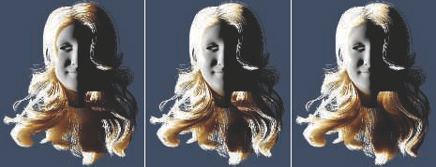

Figure 14.50. Left: using a depth diﬀerence from the ﬁrst occluder with constant extinction coef- ﬁcients results in too smooth volumetric shadows. Middle: using deep shadow maps [1953] makes it possible to achieve more transmittance variations matching the way hairs are clumped together within the hair volume. Right: combining deep shadow maps with PCSS achieves smoother volu- metric shadows based on the distance to the ﬁrst occluder (see Section 7.6 for more details). *(Image rendered using a hair model courtesy of USC-HairSalon [7**81**].)*

way to approximate multiple scattering. This ad hoc model uses fake normals (similar to bent normals), wrapped diffuse lighting, and the hairs’ base color raised to a depth- dependent power before it is multiplied with lighting, approximating color saturation after light has scattered through many strands.

A more advanced dual-scattering technique has been presented by Zinke et al. [1972]. See Figure 14.51. It is dual because it evaluates the amount of scattered light according to two factors. First, a global transmittance factor Ψ*G* is evaluated by combining the BSDF of each hair strand encountered between the shaded pixel and the light’s position. Thus, Ψ*G* gives the amount of transmittance to apply to the incoming radiance at the shaded position. This value can be evaluated on the GPU by counting the number of hairs and calculating the mean strand orientation on a light path, the latter influencing the BSDF and so also the transmittance. Accumu- lating these data can be achieved using deep opacity mapping [1953] or occupancy maps [1646]. Second, a local scattering component Ψ*L* approximates the fact that the transmitted radiance at the shaded position will scatter in the hair fibers around the current one and contribute to the radiance. Both these terms are added as Ψ*G* +Ψ*G*Ψ*L* and fed through the pixel strand BSDF to accumulate the light source contribution. This technique is more expensive, but it is an accurate real-time approximation to the light multiple scattering phenomenon within hair volumes. It can also be used with any of the BSDFs presented in this chapter.

Environment lighting is another input that is complex to evaluate for animated translucent materials. It is common to simply sample the irradiance from spherical harmonics. The lighting can also be weighted by non-directional pre-integrated ambi- ent occlusion computed from the hair at its rest position [1560]. Using the same fake

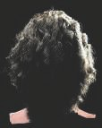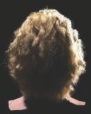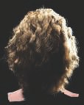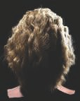

Figure 14.51. The ﬁrst two images present hair rendered using path tracing as a reference for the three hair scattering components (R, TT, TRT) in isolation and then with multiple scattering added. The last two images present results using the dual-scattering approximation: path-traced and then rendered in real time on the GPU. *(Images courtesy of Arno Zinke and Cem Yuksel [1**953**].)*

normal as for multiple scattering, Karis proposes an ad hoc model for environment lighting [863].

For more information, a comprehensive real-time hair rendering course is available online from Yuksel and Tariq [1954]. Before reading research papers and learning more details, this course will teach you all about the many areas of hair rendering such as simulation, collision, geometry, BSDF, multiple scattering, and volumetric shadows. Hair can look convincing in real-time applications. However, much research is still needed to be able to better approximate physically based environment lighting and multiple scattering in hair.

## Fur

As opposed to hair, fur is usually seen as short and semi-organized strands typically found on animals. A concept related to the method of using layers of textures for volumetric rendering is *volumetric textures*, which are volume descriptions that are represented by layers of two-dimensional, semitransparent textures [1203].

For example, Lengyel et al. [1031] use a set of eight textures to represent fur on a surface. Each texture represents a slice through a set of hairs at a given distance from the surface. The model is rendered eight times, with a vertex shader program moving each triangle slightly outward along its vertex normals each time. In this way, each successive model depicts a different height above the surface. Nested models created this way are called *shells*. This rendering technique falls apart along object silhouette edges, as the hairs break up into dots as the layers spread out. To hide this artifact, the fur is also represented by a different hair texture applied on *fins* generated along the silhouette edges. See Figure 14.52 and Figure 19.28 on page 855. The idea of silhouette fin extrusion can be used to create visual complexity for other types of models. For example, Kharlamov et al. [887] use fins and relief mapping to provide tree meshes with complex silhouettes.

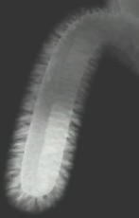 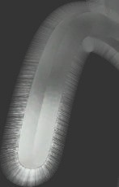 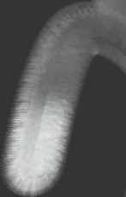

Figure 14.52. Fur using volumetric texturing. The model is rendered eight times, with the surface expanding outward a small amount each pass. On the left is the result of the eight passes. Note the hair breakup along the silhouettes. In the middle, ﬁn rendering is shown. On the right is the ﬁnal rendering, using both ﬁns and shells. *(Images from NVIDIA SDK 10 [1**300**] sample “Fur—Shells and Fins,” courtesy of NVIDIA Corporation.)*

The introduction of the geometry shader made it possible to actually extrude polyline hairs for surfaces with fur. This technique was used in *Lost Planet* [1428]. A surface is rendered and values are saved at each pixel: fur color, length, and angle. The geometry shader then processes this image, turning each pixel into a semitrans- parent polyline. By creating one hair per pixel covered, level of detail is automatically maintained. The fur is rendered in two passes. Fur pointing downward in screen space is rendered first, sorted from the bottom to the top of the screen. In this way, blending is performed correctly, back to front. In the second pass, the rest of the fur pointing up is rendered top to bottom, again blending correctly. As the GPU evolves, new techniques become possible and profitable.

It is possible to also use the techniques presented in the previous sections. Strands can be rendered as quads extruded as geometry from a skinned surface such as for Chewbacca in the *Star Wars Battlefront* games or for the TressFX *Rat demo* [36]. When rendering hair strands as thin filaments, Ling-Qi et al. [1052] have proven that it is not enough to simulate hair as a uniform cylinder. For animal fur, the medulla is much darker and larger relative to the hair radius. This reduces the impact of light scattering. As such, a double-cylinder fiber BSDF model is presented that simulates a wider range of hair and fur [1052]. It considers more detailed paths such as TttT, TrRrT, TttRttT, and more, where lowercase letters represent interactions with the medulla. This complex approach results in more realistic visuals, especially for simulation of rougher fur and elaborate scattering effects. Such fur rendering

techniques involve the rasterization of many strand instances, and anything that can help to reduce the render time is welcome. Ryu [1523] proposes to decimate the number of strand instances rendered as a level of detail scheme dependent on motion magnitude and distance. This method was used for offline movie rendering and appears to be straightforward to apply in real-time applications.

# Uniﬁed Approaches

We have reached a point where volumetric rendering has become affordable in real- time applications. What may be possible to achieve in the future?

At the beginning of this chapter we stated that “everything is scattering.” Looking at participating media materials, it is possible to use a high scattering coefficient *σs* in order to achieve a opaque medium. This, together with a complex anisotropic phase function driving diffuse and specular responses, would result in an opaque surface material. In light of that, would there be a way to unify solid and volumetric material representations?

As of today, volumetric and opaque material rendering are separated because the current computational capabilities of GPUs force us to use specific approaches that are efficient for some use cases. We use meshes for opaque surfaces, alpha-blended meshes for transparent materials, particle billboards for smoke volumes, and ray marching for some of the volumetric lighting effects within participating media.

As hinted at by Dupuy et al. [397], it may be possible to represent solid and participating media using a unified representation. One possible representation is to use symmetrical GGX [710] (SGGX), an extension of the GGX normal distribution function presented in Section 9.8.1. In this case, the microflake theory representing oriented flake particles within a volume replaces the microfacet theory used for surface normal distribution representation. In a sense, level of detail would become more practical, as compared to meshes, because it can simply become a volume filtering over the material properties. That could lead to more coherent lighting and representation of large detailed worlds while maintaining lighting, shape, occlusion, or transmittance applied over the background. For example, as shown in Figure 14.53, rendering a forest with a volume filtered tree representation would remove visible tree mesh LOD switching, providing a smooth filtering of thin geometry and avoiding aliasing caused by branches, while also providing the correct occlusion value over the background considering the underlying tree geometry within each voxel.

# Further Reading and Resources

These resources have been mentioned throughout the text, but are worth highlight- ing here as particularly noteworthy. General volumetric rendering is explained in the

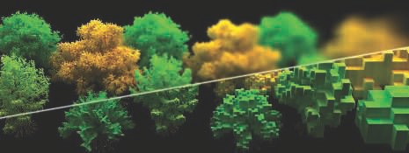

Figure 14.53. A forest rendered using SGGX at the top, with decreasing levels of detail from left to right. The bottom part shows the raw unﬁltered voxels. *(Images courtesy of Eric Heitz et al. [7**10**].)*

course notes of Fong et al. [479], providing considerable background theory, optimiza- tion details, and solutions used in movie production. For sky and cloud rendering, this chapter builds on Hillaire’s extensive course notes [743], which have more details than we could include here. The animation of volumetric material is outside the scope of this book. We recommend that the reader reads these articles about real-time simula- tions [303, 464, 1689] and especially the complete book from Bridson [197]. McGuire’s presentation [1182], along with McGuire and Mara’s article [1185], gives a wider un- derstanding of transparency-related effects and a range of strategies and algorithms that can be used for various elements. For hair and fur rendering and simulation, we again refer the reader to the extensive course notes by Yuksel and Tariq [1954].



Chapter 15

Non-Photorealistic Rendering

*“Using a term like ‘nonlinear science’ is like referring to the bulk of zoology as ‘the study of nonelephant animals.’ ”*

—Stanislaw Ulam

Photorealistic rendering attempts to make an image indistinguishable from a photo- graph. *Non-photorealistic rendering* (NPR), also called stylized rendering, has a wide range of goals. One objective of some forms of NPR is to create images similar to technical illustrations. Only those details relevant to the goal of the particular appli-

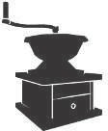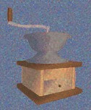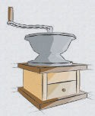

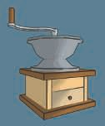 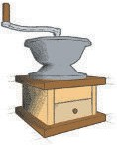 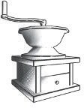

Figure 15.1. A variety of non-photorealistic rendering styles applied to a coﬀee grinder. *(Generated using LiveArt from Viewpoint DataLabs.)*

651

cation are the ones that should be displayed. For example, a photograph of a shiny Ferrari engine may be useful in selling the car to a customer, but to repair the engine, a simplified line drawing with the relevant parts highlighted may be more meaningful (as well as less costly to print).

Another area of NPR is in the simulation of painterly styles and natural media, e.g., pen and ink, charcoal, and watercolor. This is a huge field that lends itself to an equally huge variety of algorithms that attempt to capture the feel of various media. Some examples are shown in Figure 15.1. Two older books provide coverage of technical and painterly NPR algorithms [563, 1719]. Given this breadth, we focus here on techniques for rendering strokes and lines. Our goal is to give a flavor of some algorithms used for NPR in real time. This chapter opens with a detailed discussion of ways to implement a cartoon rendering style, then discusses other themes within the field of NPR. The chapter ends with a variety of line rendering techniques.

# Toon Shading

Just as varying the font gives a different feel to the text, different styles of rendering have their own mood, meaning, and vocabulary. There has been a large amount of attention given to one particular form of NPR, *cel* or *toon rendering*. Since this style is identified with cartoons, it has connotations of fantasy and childhood. At its simplest, objects are drawn with solid lines separating areas of different solid colors. One reason this style is popular is what McCloud, in his classic book *Understanding Comics* [1157], calls “amplification through simplification.” By simplifying and stripping out clutter, one can amplify the effect of information relevant to the presentation. For cartoon characters, a wider audience will identify with those drawn in a simple style.

The toon rendering style has been used in computer graphics for decades to in- tegrate three-dimensional models with two-dimensional cel animation. It lends itself well to automatic generation by computer because it is easily defined, compared to other NPR styles. Many video games have used it to good effect [250, 1224, 1761]. See Figure 15.2.

The outlines of objects are often rendered in a black color, which amplifies the cartoon look. Finding and rendering these outlines is dealt with in the next section. There are several different approaches to toon surface shading. The two most common methods are to fill the mesh areas with solid (unlit) color or to use a two-tone approach, representing lit and shadowed areas. The two-tone approach, sometimes called *hard shading*, is simple to perform in a pixel shader by using a lighter color when the dot product of the shading normal and light source direction are above some value, and a darker tone if not. When the illumination is more complex, another approach is to quantize the final image itself. Also called *posterization*, this is a process of taking a continuous range of values and converting to a few tones, with a sharp change between each. See Figure 15.3. Quantizing RGB values can cause unpleasant hue shifts, as each separate channel changes in a way not closely related to the others. Working a hue-

*15.1. Toon Shading* 653

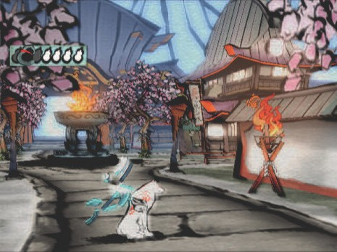

Figure 15.2. An example of real-time NPR rendering from the game *Okami*. *(Image courtesy of Capcom Entertainment, Inc.)*

preserving color space such as HSV, HSL, or Y’CbCr is a better choice. Alternately, a one-dimensional function or texture can be defined to remap intensity levels to specific shades or colors. Textures can also be preprocessed using quantization or other filters. Another example, with more color levels, is shown in Figure 15.16 on page 665.

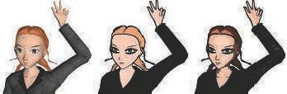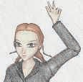

basic solid posterization pencil

Figure 15.3. The basic rendering on the left has solid ﬁll, posterization, and pencil shading tech- niques applied in turn. *(Jade2 model by Quidam, published by wismo [1**449**], Creative Commons 2.5 attribution license.)*

Barla et al. [104] add view-dependent effects by using two-dimensional maps in place of one-dimensional shade textures. The second dimension is accessed by the depth or orientation of the surface. This allows objects to smoothly soften in contrast when distant or moving rapidly, for example. This algorithm, combined with a variety of other shading equations and painted textures, is used in the game *Team Fortress 2* to give a blend of cartoon and realistic styles [1224]. Variations on toon shaders can be used for other purposes, such as for exaggerating contrast when visualizing features on surfaces or terrain [1520].

# Outline Rendering

Algorithms used for cel edge rendering reflect some of the major themes and techniques of NPR. Our goal here is to present algorithms that give a flavor of the field. Methods used can be roughly categorized as based on surface shading, procedural geometry, image processing, geometric edge detection, or a hybrid of these.

There are several different types of edges that can be used in toon rendering:

A *boundary* or *border edge* is one not shared by two triangles, e.g., the edge of a sheet of paper. A solid object typically has no boundary edges.

•

A *crease*, *hard*, or *feature edge* is one that is shared by two triangles, and the angle between the two triangles (called the *dihedral angle*) is greater than some predefined value. A good default crease angle is 60 degrees [972]. As an example, a cube has crease edges. Crease edges can be further subcategorized into *ridge* and *valley* edges.

•

A *material edge* appears when the two triangles sharing it differ in material or otherwise cause a change in shading. It also can be an edge that the artist wishes to always have displayed, e.g., forehead lines or a line to separate the same colored pants and shirt.

•

A *contour edge* is one in which the two neighboring triangles face in different directions compared to some direction vector, typically one from the eye.

•

A *silhouette edge* is a contour edge along the outline of the object, i.e., it separates the object from the background in the image plane.

•

See Figure 15.4. This categorization is based on common usage within the litera- ture, but there are some variations, e.g., what we call crease and material edges are sometimes called boundary edges elsewhere.

We differentiate here between contour and silhouette edges. Both are edges along which one part of the surface faces the viewer, the other part faces away. Silhouette edges are a subset of contour edges, those which separate the object from another object or the background. For example, in a side view of a head, the ears form

*CS*

*B*

*B*

*B*

*C*

*B*

*C*

*B*

*B*

*CS*

*C*

*M*

*M*

*CS*

*CS*

Figure 15.4. A box open on the top, with a stripe on the front. The boundary (*B*), crease (*C*), material (*M* ), and silhouette (*S*) edges are shown. None of the boundary edges are considered silhouette edges by the deﬁnitions given, as these edges have only one adjoining polygon.

contour edges, even though they appear within the silhouette outline of the head. Other examples in Figure 15.3 include the nose, two bent fingers, and where the hair parts. In some of the early literature, contour edges are referred to as silhouettes, but the full class of contour edges is usually meant. Also, contour edges should not be confused with contour lines used on topographical maps.

Note that boundary edges are not the same as contour or silhouette edges. Con- tour and silhouette edges are defined by a view direction, while boundary edges are view-independent. *Suggestive contours* [335] are formed by locations that are almost a contour from the original viewpoint. They provide additional edges that help convey the object’s shape. See Figure 15.5. While our focus here is primarily on detect-

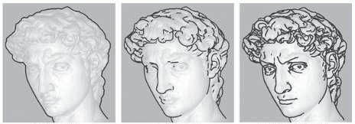

Figure 15.5. From left to right: silhouette, contour, and contour together with suggestive contour edges. *(Images courtesy of Doug DeCarlo, Adam Finkelstein, Szymon Rusinkiewicz, and Anthony Santella.)*

ing and rendering contour edges, considerable work has been done for other types of strokes [281, 1014, 1521]. We also focus primarily on finding such edges for polyg- onal models. B´enard et al. [132] discuss approaches for finding contours of models comprised of subdivision surfaces or other higher-order definitions.

## Shading Normal Contour Edges

In a similar fashion to the surface shader in Section 15.1, the dot product between the shading normal and the direction to the eye can be used to give a contour edge [562]. If this value is near zero, then the surface is nearly edge-on to the eye and so is likely to be near a contour edge. Color such areas black, falling off to white as the dot product increases. See Figure 15.6. Before programmable shaders, this algorithm was implemented using a spherical environment map with a black ring, or coloring the topmost levels of a mipmap pyramid texture black [448]. This type of shading today is implemented directly in a pixel shader by going to black as the screen normal becomes perpendicular to the view direction.

This shading is in a sense the opposite of rim lighting, where light illuminates the outline of an object; here the scene is lit from the eye’s location and the dropoff is exaggerated, darkening the edges. It can also be thought of as a *thresholding* filter in image processing, where the image is converted to black wherever the surfaces are below a certain intensity, and to white otherwise.

A feature or drawback of this method is that contour lines are drawn with variable width, depending on the curvature of the surface. This method works for curved surface models without crease edges, where areas along the silhouette, for example, will usually have pixels with normals pointing nearly perpendicular to the view direction.

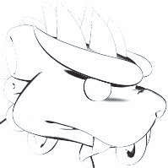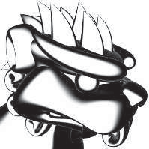

Figure 15.6. Contour edges shaded by darkening the surface as its shading normal becomes perpen- dicular to the view direction. By widening the falloﬀ angle, a thicker edge is displayed. *(Images courtesy of Kenny Hoff.)*

The algorithm fails on a model such as a cube, since the surface area near a crease edge will not have this property. It can also break up and look bad even on curved surfaces, as when the object is distant and some normals sampled near the contour edges may not be nearly perpendicular. Goodwin et al. [565] note how this basic concept nonetheless has validity as a visual cue, and discuss how lighting, curvature, and distance can be combined to determine stroke thickness.

## Procedural Geometry Silhouetting

One of the first techniques for real-time contour edge rendering was presented by Rossignac and van Emmerik [1510], and later refined by Raskar and Cohen [1460]. The general idea is to render the frontfaces normally, then render the backfaces in a way as to make their contour edges visible. There are a variety of methods for rendering these backfaces, each with its own strengths and weaknesses. Each method has as its first step that the frontfaces are drawn. Then frontface culling is turned on and backface culling turned off, so that only backfaces are rendered.

One method to render the contours is to draw only the edges (not the faces) of the backfaces. Using biasing or other techniques (Section 15.4) ensures that some of these lines are drawn just in front of the frontfaces. In this way, only the edges where front- and backfaces meet are visible [969, 1510].

One way to make these lines wider is to render the backfaces themselves in black, again biasing forward. Raskar and Cohen give several biasing methods, such as trans- lating by a fixed amount, or by an amount that compensates for the nonlinear nature of the *z*-depths, or using a depth-slope bias call such as OpenGL’s glPolygonOffset. Lengyel [1022] discusses how to provide finer depth control by modifying the perspec- tive matrix. A problem with all these methods is that they do not create lines with a uniform width. To do so, the amount to move forward depends not only on the backface, but also on the neighboring frontface(s). See Figure 15.7. The slope of the backface can be used to bias the polygon forward, but the thickness of the line will also depend on the angle of the frontface.

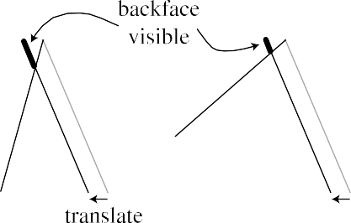



Figure 15.7. The *z*-bias method of silhouetting, done by translating the backface forward. If the frontface is at a diﬀerent angle, as shown on the right, a diﬀerent amount of the backface is visible. *(Illustration after Raskar and Cohen [1**460**].)*

Figure 15.8. Triangle fattening. On the left, a backface triangle is expanded along its plane. Each edge moves a diﬀerent amount in world space to make the resulting edge the same thickness in screen space. For thin triangles, this technique falls apart, as one corner becomes elongated. On the right, the triangle edges are expanded and joined to form mitered corners to avoid this problem.

Raskar and Cohen [1460, 1461] solve this neighbor dependency problem by instead fattening each backface triangle out along its edges by the amount needed to see a consistently thick line. That is, the slope of the triangle and the distance from the viewer determine how much the triangle is expanded. One method is to expand the three vertices of each triangle outward along its plane. A safer method of rendering the triangle is to move each edge of the triangle outward and connect the edges. Doing so avoids having the vertices stick far away from the original triangle. See Figure 15.8. Note that no biasing is needed with this method, as the backfaces expand beyond the edges of the frontfaces. See Figure 15.9 for results from the three methods. This fattening technique is more controllable and consistent, and has been used success- fully for character outlining in video games such as *Prince of Persia* [1138] and *Afro Samurai* [250].

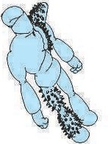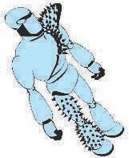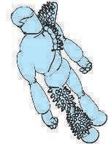

Figure 15.9. Contour edges rendered with backfacing edge drawing with thick lines, *z*-bias, and fattened triangle algorithms. The backface edge technique gives poor joins between lines and nonuni- form lines due to biasing problems on small features. The *z*-bias technique gives nonuniform edge width because of the dependence on the angles of the frontfaces. *(Images courtesy of Raskar and Cohen [1**46**0].)*

render frontfaces

expand and render backfaces in black

eye



Figure 15.10. The triangle shell technique creates a second surface by shifting the surface along its vertex normals.

In the method just given, the backface triangles are expanded along their original planes. Another method is to move the backfaces outward by shifting their vertices along the shared vertex normals, by an amount proportional to their *z*-distance from the eye [671]. This is referred to as the shell or halo method, as the shifted backfaces form a shell around the original object. Imagine a sphere. Render the sphere normally, then expand the sphere by a radius that is 5 pixels wide with respect to the sphere’s center. That is, if moving the sphere’s center one pixel is equivalent to moving it in world space by 3 millimeters, then increase the radius of the sphere by 15 millimeters. Render only this expanded version’s backfaces in black. The contour edge will be 5 pixels wide. See Figure 15.10. Moving vertices outward along their normals is a perfect task for a vertex shader. This type of expansion is sometimes called shell mapping. The method is simple to implement, efficient, robust, and gives steady performance. See Figure 15.11. A forcefield or halo effect can be made by further expanding and shading these backfaces dependent on their angle.

This shell technique has several potential pitfalls. Imagine looking head-on at a cube so that only one face is visible. Each of the four backfaces forming the contour edge will move in the direction of its corresponding cube face, so leaving gaps at the corners. This occurs because while there is a single vertex at each corner, each face has a different vertex normal. The problem is that the expanded cube does not truly form a shell, because each corner vertex is expanding in a different direction. One solution is to force vertices in the same location to share a single, new, average vertex normal. Another technique is to create degenerate geometry at the creases that then gets expanded into triangles with area. Lira et al. [1053] use an additional threshold texture to control how much each vertex is moved.

Shell and fattening techniques waste some fill, since all the backfaces are sent down the pipeline. Other limitations of all these techniques is that there is little control over the edge appearance, and semitransparent surfaces are tricky to render correctly, depending on the transparency algorithm used.

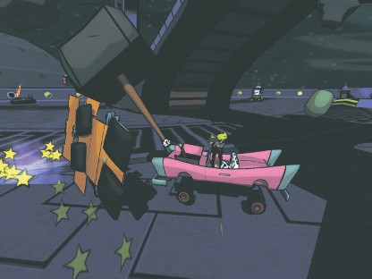

Figure 15.11. An example of real-time toon-style rendering from the game *Cel Damage*, using backface shell expansion to form contour edges, along with explicit crease edge drawing. *(Image courtesy of Pseudo Interactive Inc.)*

One worthwhile feature of this entire class of geometric techniques is that no connectivity information or edge lists are needed during rendering. Each triangle is processed independently from the rest, so such techniques lend themselves to GPU implementation [1461].

This class of algorithms renders only contour edges. Raskar [1461] gives a clever solution for drawing ridge crease edges on deforming models without having to create and access an edge connectivity data structure. The idea is to generate an additional polygon along each edge of the triangle being rendered. These edge polygons are bent away from the triangle’s plane by the user-defined critical dihedral angle that determines when a crease should be visible. If at any given moment two adjoining triangles are at greater than this crease angle, the edge polygons will be visible, else they will be hidden by the triangles. See Figure 15.12. Valley edges are possible with a similar technique, but require a stencil buffer and multiple passes.

## Edge Detection by Image Processing

The algorithms in the previous section are sometimes classified as image-based, as the screen resolution determines how they are performed. Another type of algorithm is

Figure 15.12. A side view of two triangles joined at an edge, each with a small “ﬁn” attached. As the two triangles bend along the edge, the ﬁns move toward becoming visible. On the right the ﬁns are exposed. Painted black, these appear as a ridge edge.

more directly image-based, in that it operates entirely on data stored in image buffers and does not modify (or even directly know about) the geometry in the scene.

Saito and Takahashi [1528] first introduced this G-buffer concept, which is also used for deferred shading (Section 20.1). Decaudin [336] extended the use of G-buffers to perform toon rendering. The basic idea is simple: NPR can be done by performing image processing algorithms on various buffers of information. Many contour-edge locations can be found by looking for discontinuities in neighboring *z*-buffer values. Discontinuities in neighboring surface normal values often signal the location of con- tour and boundary edges. Rendering the scene in ambient colors or with object identification values can be used to detect material, boundary, and true silhouette edges.

Detecting and rendering these edges consists of two parts. First, the scene’s geom- etry is rendered, with the pixel shader saving depth, normal, object IDs, or other data as desired to various render targets. Post-processing passes are then performed, in a similar way as described in Section 12.1. A post-processing pass samples the neigh- borhood around each pixel and outputs a result based on these samples. For example, imagine we have a unique identification value for each object in the scene. At each pixel we could sample this ID and compare it to the four adjacent pixel ID values at the corners of our test pixel. If any of the IDs differ from the test pixel’s ID, output black, else output white. Sampling all eight neighbor pixels is more foolproof, but at a higher sampling cost. This simple kind of test can be used to draw the boundary and outline edges (true silhouettes) of most objects. Material IDs could be used to find material edges.

Contour edges can be found by using various filters on normal and depth buffers. For example, if the difference in depths between neighboring pixels is above some threshold, a contour edge is likely to exist and so the pixel is made black. Rather than a simple decision about whether the neighboring pixels match our sample, other more elaborate edge detection operators are needed. We will not discuss here the pros and cons of various edge detection filters, such as Roberts cross, Sobel, and Scharr, as the image processing literature covers these extensively [559, 1729]. Because the results of such operators are not necessarily boolean, we can adjust their thresholds or fade between black and white when in some zone. Note that the normal buffer can also detect crease edges, as a large difference between normals can signify either a contour or a crease edge. Thibault and Cavanaugh [1761] discuss how they use this technique

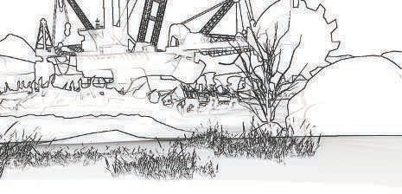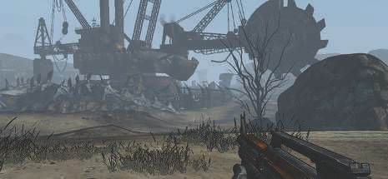

Figure 15.13. Modiﬁed Sobel edge detection in the game *Borderlands*. The ﬁnal released version (not shown here) further improved the look by masking out edges for the grass in the foreground [1761]. *(Images courtesy of Gearbox Software, LLC.)*

with the depth buffer for the game *Borderlands*. Among other techniques, they modify the Sobel filter so that it creates single-pixel-wide outlines and the depth computation to improve precision. See Figure 15.13. It is also possible to go the other direction, adding outlines only around shadows by ignoring edges where the neighboring depths differ considerably [1138].

The *dilation operator* is a type of morphological operator that is used for thickening detected edges [226, 1217]. After the edge image is generated, a separate pass is applied. At each pixel, the pixel’s value and its surrounding values to within some radius are examined. The darkest pixel value found is returned as output. In this way, a thin black line will be thickened by the diameter of the area searched. Multiple

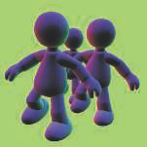 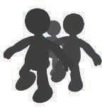 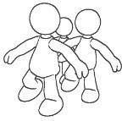

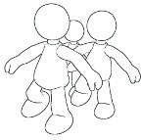 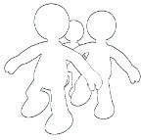 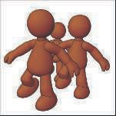

Figure 15.14. The normal map (upper left) and depth map (upper middle) have Sobel edge detection applied to their values, with results shown in the lower left and lower middle, respectively. The image in the upper right is a thickened composite using dilation. The ﬁnal rendering in the lower right is made by shading the image with Gooch shading and compositing in the edges. *(Images courtesy of Drew Card and Jason L. Mitchell, ATI Technologies Inc.)*

passes can be applied to further thicken lines, the trade-off being that the cost of the additional pass is offset by needing considerably fewer samples for each pass. Different results can have different thicknesses, e.g., the silhouette edges could be made thicker than the other contour edges. The related *erosion operator* can be used for thinning lines or other effects. See Figure 15.14 for some results.

This type of algorithm has several advantages. It handles all types of surfaces, flat or curved, unlike most other techniques. Meshes do not have to be connected or even consistent, since the method is image-based.

There are relatively few flaws with this type of technique. For nearly edge-on surfaces, the *z*-depth comparison filter can falsely detect a contour-edge pixel across the surface. Another problem with *z*-depth comparison is that if the differences are minimal, then the contour edge can be missed. For example, a sheet of paper on a desk will usually have its edges missed. Similarly, the normal map filter will miss the edges of this piece of paper, since the normals are identical. This is still not foolproof; for example, a piece of paper folded onto itself will create undetectable edges where the edges overlap [725]. Lines generated show stair-step aliasing, but the various

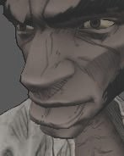 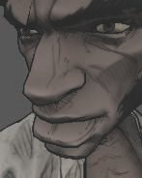 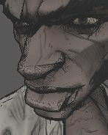

Figure 15.15. Various edge methods. Feature edges such as wrinkles are part of the texture itself, added by the artist in advance. The silhouette of the character is generated with backface extrusion. The contour edges are generated using image processing edge detection, with varying weights. The left image was generated with too little weight, so these edges are faint. The middle shows outlines, on the contour edges of the nose and lips in particular. The right displays artifacts from too great a weight [250]. *(Afro Samurai* ⓍR *&* Ⓧc *2006 TAKASHI OKAZAKI, GONZO / SAMURAI PROJECT.*

*Program* Ⓧc *2009 BANDAI NAMCO Entertainment America Inc.)*

morphological antialiasing techniques described in Section 5.4.2 work well with this high-contrast output, as well as on techniques such as posterization, to improve edge quality.

Detection can also fail in the opposite way, creating edges where none should exist. Determining what constitutes an edge is not a foolproof operation. For example, imagine the stem of a rose, a thin cylinder. Close up, the stem normals neighboring our sample pixel do not vary all that much, so no edge is detected. As we move away from the rose, the normals will vary more rapidly from pixel to pixel, until at some point a false edge detection may occur near the edges because of these differences. Similar problems can happen with detecting edges from depth maps, with the perspective’s effect on depth being an additional factor needing compensation. Decaudin [336] gives an improved method of looking for changes by processing the gradient of the normal and depth maps rather than just the values themselves. Deciding how various pixel differences translate into color changes is a process that often needs to be tuned for the content [250, 1761]. See Figure 15.15.

Once the strokes are generated, further image processing can be performed as desired. Since the strokes can be created in a separate buffer, they can be modified on their own, then composited atop the surfaces. For example, noise functions can be used to fray and wobble the lines and the surfaces separately, creating small gaps between the two and giving a hand-drawn look. The heightfield of the paper can be used to affect the rendering, having solid materials such as charcoal deposited at the tops of bumps or watercolor paint pooled in the valleys. See Figure 15.16 for an example.

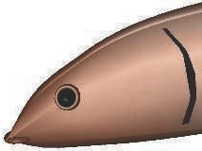 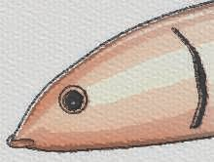

Figure 15.16. The ﬁsh model on the left is rendered on the right using edge detection, posterization, noise perturbation, blurring, and blending atop the paper. *(Images courtesy of Autodesk, Inc.)*

We have focused here on detecting edges using geometric or other non-graphical data, such as normals, depths, and IDs. Naturally, image processing techniques were developed for images, and such edge detection techniques can be applied to color buffers. One approach is called *difference of Gaussians* (DoG), where the image is processed twice with two different Gaussian filters and one is subtracted from the other. This edge detection method has been found to produce particularly pleasing results for NPR, used to generate images in a variety of artistic styles such as pencil shading and pastels [949, 1896, 1966].

Image post-processing operators feature prominently within many NPR techniques simulating artistic media such as watercolors and acrylic paints. There is considerable research in this area, and for interactive applications much of the challenge is in trying to do the most with the fewest number of texture samples. Bilateral, mean-shift, and Kuwahara filters can be used on the GPU for preserving edges and smoothing areas to appear as if painted [58, 948]. Kyprianidis et al. [949] provide a thorough review and a taxonomy of image processing effects for the field. The work by Montesdeoca et al. [1237] is a fine example of combining a number of straightforward techniques into a watercolor effect that runs at interactive rates. A model rendered with a watercolor style is shown in Figure 15.17.

## Geometric Contour Edge Detection

A problem with the approaches given so far is that the stylization of the edges is limited at best. We cannot easily make the lines look dashed, let alone look hand- drawn or like brush strokes. For this sort of operation, we need to find the contour edges and render them directly. Having separate, independent edge entities makes it possible to create other effects, such as having the contours jump in surprise while the mesh is frozen in shock.

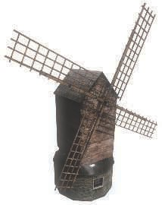 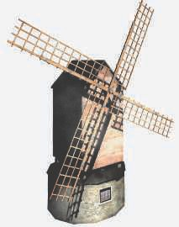

Figure 15.17. On the left, a standard realistic render. On the right, the watercolor style softens textures through mean-shift color matching, and increases contrast and saturation, among other techniques. *(Watercolor image courtesy of Autodesk, Inc.)*

A contour edge is one in which one of the two neighboring triangles faces toward the viewer and the other faces away. The test is

(n0 · v)(n1 · v) *<* 0*,* (15.1)

where n0 and n1 are the two triangle normals and v is the view direction from the eye to the edge (i.e., to either endpoint). For this test to work correctly, the surface must be consistently oriented (Section 16.3).

The brute-force method for finding the contour edges in a model is to run through the list of edges and perform this test [1130]. Lander [972] notes that a worthwhile optimization is to identify and ignore edges that are inside planar polygons. That is, given a connected triangle mesh, if the two neighboring triangles for an edge lie in the same plane, the edge cannot possibly be a contour edge. Implementing this test on a simple clock model dropped the edge count from 444 edges to 256. Furthermore, if the model defines a solid object, concave edges can never be contour edges. Buchanan and Sousa [207] avoid the need for doing separate dot product tests for each edge by reusing the dot product test for each individual face.

Detecting contour edges each frame from scratch can be costly. If the camera view and the objects move little from frame to frame, it is reasonable to assume that the contour edges from previous frames might still be valid contour edges. Aila and Miettinen [13] associate a valid distance with each edge. This distance is how far the

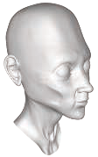 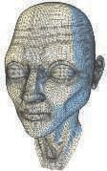 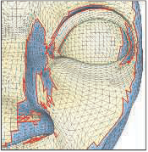

Figure 15.18. Contour loops. On the left is the camera’s view of the model. The middle shows the triangles facing away from the camera in blue. A close-up of one area of the face is shown on the right. Note the complexity and how some contour loops are hidden behind the nose. *(Model courtesy of Chris Landreth, images courtesy of Pierre B´enard and Aaron Hertzmann [1**32**].)*

viewer can move and still have the contour edge maintain its state. In any solid model each separate contour always consists of a single closed curve, called a *silhouette loop* or, more properly, a *contour loop*. For contours inside the object’s bounds, some part of the loop may be obscured. Even the actual silhouette may consist of a few loops, with parts of loops being inside the outline or hidden by other surfaces. It follows that each vertex must have an even number of contour edges [23]. See Figure 15.18. Note how the loops are often quite jagged in three dimensions when following mesh edges, with the *z*-depth varying noticeably. If edges forming smoother curves are desired, such as for varying thickness by distance [565], additional processing can be done to interpolate among the triangle’s normals to approximate the true contour edge inside a triangle [725, 726].

Tracking loop locations from frame to frame can be faster than recreating loops from scratch. Markosian et al. [1125] start with a set of loops and uses a randomized search algorithm to update this set as the camera moves. Contour loops are also created and destroyed as the model changes orientation. Kalnins et al. [848] note that when two loops merge, corrective measures need to be taken or a noticeable jump from one frame to the next will be visible. They use a pixel search and “vote” algorithm to attempt to maintain contour coherence from frame to frame.

Such techniques can give serious performance increases, but can be inexact. Linear methods are exact but expensive. Hierarchical methods that use the camera to access contour edges combine speed and precision. For orthographic views of non-animated models, Gooch et al. [562] use a hierarchy of Gauss maps for determining contour edges. Sander et al. [1539] use an *n*-ary tree of normal cones (Section 19.3). Hertzmann and Zorin [726] use a dual-space representation of the model that allows them to impose a hierarchy on the model’s edges.

All these explicit edge detection methods are CPU intensive and have poor cache coherency, since edges forming a contour are dispersed throughout the edge list. To avoid these costs, the vertex shader can be used to detect and render contour edges [226]. The idea is to send every edge of the model down the pipeline as two triangles forming a degenerate quadrilateral, with the two adjoining triangle normals attached to each vertex. When an edge is found to be part of the contour, the quadri- lateral’s points are moved so that it is no longer degenerate (i.e., is made visible). This thin quadrilateral *fin* is then drawn. This technique is based on the same idea as that described for finding contour edges for shadow volume creation (Section 7.3). If the geometry shader is a part of the pipeline, these additional fin quadrilaterals do not need to be stored but can be generated on the fly [282, 299]. A naive implementation will leave chinks and gaps between the fins, which can be corrected by modifying the shape of the fin [723, 1169, 1492].

## Hidden Line Removal

Once the contours are found, the lines are rendered. An advantage of explicitly finding the edges is that you can stylize these as pen strokes, paint strokes, or any other medium you desire. Strokes can be basic lines, textured impostors (Section 13.6.4), sets of primitives, or whatever else you wish to try.

A further complication with attempting to use geometric edges is that not all these edges are actually visible. Rendering surfaces to establish the *z*-buffer can mask hidden geometric edges, which may be sufficient for simple styles such as dotted lines. Cole and Finkelstein [282] extend this for quadrilaterals representing lines by sampling the *z*-depths along the spine of the line itself. However, with these methods each point along the line is rendered independently, so no well-defined start and end locations are known in advance. For contour loops or other edges where the line segments are meant to define brush strokes or other continuous objects, we need to know when each stroke first appears and when it disappears. Determining visibility for each line segment is known as *hidden line rendering*, where a set of line segments is processed for visibility and a smaller set of (possibly clipped) line segments is returned.

Northrup and Markosian [1287] attack this problem by rendering all the object’s triangles and contour edges and assigning each a different identification number. This ID buffer is read back and the visible contour edges are determined from it. These visible segments are then checked for overlaps and linked together to form smooth stroke paths. This approach works if the line segments on the screen are short, but it does not include clipping of the line segments themselves. Stylized strokes are then rendered along these reconstructed paths. The strokes themselves can be stylized in many different ways, including effects of taper, flare, wiggle, overshoot, and fading, as well as depth and distance cues. An example is shown in Figure 15.19.

Cole and Finkelstein [282] present a visibility calculation method for a set of edges. They store each line segment as two world-space coordinate values. A series of passes runs a pixel shader over the whole set of segments, clipping and determining the length

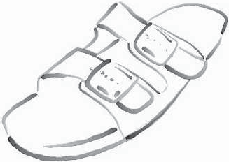

Figure 15.19. An image produced using Northrup and Markosian’s hybrid technique. Contour edges are found, built into chains, and rendered as strokes. *(Image courtesy of Lee Markosian.)*

in pixels of each, then creating an atlas for each of these potential pixel locations and determining visibility, and then using this atlas to create visible strokes. While complex, the process is relatively fast on the GPU and provides sets of visible strokes that have known beginning and end locations.

Stylization often consists of applying one or more premade textures to line quadri- laterals. Rougier [1516] discusses a different approach, procedurally rendering dashed patterns. Each line segment accesses a texture that stores all dashed patterns desired. Each pattern is encoded as a set of commands specifying the dashed pattern along with the endcap and join types used. Using the quadrilateral’s texture coordinates, each pattern controls a series of tests by the shader for how much of the line covers the pixel at each point in the quadrilateral.

Determining the contour edges, linking them into coherent chains, and then de- termining visibility for each chain to form a stroke is difficult to fully parallelize. An additional problem when producing high-quality line stylization is that for the next frame each stroke will be drawn again, changing length or possibly appearing for the first time. B´enard et al. [130] present a survey of rendering methods that provide temporal coherence for strokes along edges and patterns on surfaces. This is not a solved problem and can be computationally involved, so research continues [131].

# Stroke Surface Stylization

While toon rendering is a popular style to attempt to simulate, there is an infinite variety of other styles to apply to surfaces. Effects can range from modifying realistic

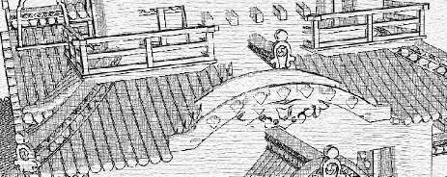

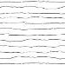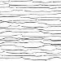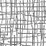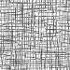

Figure 15.20. An image generated by using a palette of textures, a paper texture, and contour edge rendering. *(Reprinted by permission of Adam Lake and Carl Marshall, Intel Corporation, copyright Intel Corporation 2002.)*

textures [905, 969, 973] to having the algorithm procedurally generate geometric ornamentation from frame to frame [853, 1126]. In this section, we briefly survey techniques relevant to real-time rendering.

Lake et al. [966] discuss using the diffuse shading term to select which texture is used on a surface. As the diffuse term gets darker, a texture with a darker impression is used. The texture is applied with screen-space coordinates to give a hand-drawn look. To further enhance the sketched look, a paper texture is also applied in screen space to all surfaces. See Figure 15.20. A major problem with this type of algorithm is the *shower door effect*, where the objects look like they are viewed through pat- terned glass during animation. Objects feel as though they are swimming through the texture. Breslav et al. [196] maintain a two-dimensional look for the textures by determining what image transform best matches the movements of some underlying model locations. This can maintain a connection with the screen-based nature of the fill pattern while giving a stronger connection with the object.

One solution is obvious: Apply textures directly to the surface. The challenge is that stroke-based textures need to maintain a relatively uniform stroke thickness and density to look convincing. If the texture is magnified, the strokes appear too thick; if it is minified, the strokes are either blurred away or are thin and noisy (depending on whether mipmapping is used). Praun et al. [1442] present a real-time method of generating stroke-textured mipmaps and applying these to surfaces in a smooth fashion. Doing so maintains the stroke density on the screen as the object’s distance

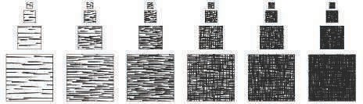

Figure 15.21. *Tonal art maps* (TAMs). Strokes are drawn into the mipmap levels. Each mipmap level contains all the strokes from the textures to the left and above it. In this way, interpolation between mip levels and adjoining textures is smooth. *(Images courtesy of Emil Praun, Princeton University.)*

changes. The first step is to form the textures to be used, called *tonal art maps* (TAMs). This is done by drawing strokes into the mipmap levels. See Figure 15.21. Klein et al. [905] use a related idea in their “art maps” to maintain stroke size for NPR textures. With these textures in place, the model is rendered by interpolating between the tones needed at each vertex. This technique results in images with a hand-drawn feel [1441]. See Figure 15.22.

Webb et al. [1858] present two extensions to TAMs that give better results, one using a volume texture, which allows the use of color, the other using a thresholding scheme, which improves antialiasing. Nuebel [1291] gives a related method of perform- ing charcoal rendering. He uses a noise texture that also goes from dark to light along

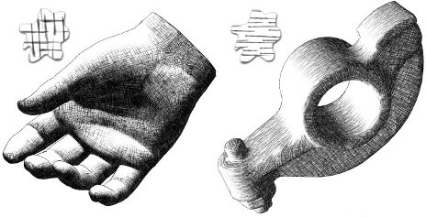

Figure 15.22. Two models rendered using *tonal art maps* (TAMs). The swatches show the lapped texture pattern used to render each. *(Images courtesy of Emil Praun, Princeton University.)*

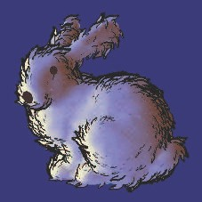 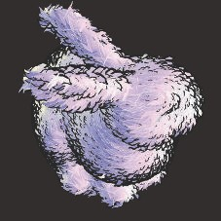

Figure 15.23. Two diﬀerent graftal styles render the Stanford bunny. *(Images courtesy of Bruce Gooch and Matt Kaplan, University of Utah.)*

one axis. The intensity value accesses the texture along this axis. Lee et al. [1009] use TAMs and other techniques to generate impressive images that appear drawn by pencil.

With regard to strokes, many other operations are possible than those already discussed. To give a sketched effect, edges can be jittered [317, 972, 1009] or can overshoot their original locations, as seen in the upper right and lower middle images in Figure 15.1 on page 651.

Girshick et al. [538] discuss rendering strokes along the principal curve direction lines on a surface. That is, from any given point on a surface, there is a *first principal direction* tangent vector that points in the direction of maximum curvature. The *second principal direction* is the tangent vector perpendicular to this first vector and gives the direction in which the surface is least curved. These direction lines are important in the perception of a curved surface. They also have the advantage of needing to be generated only once for static models, since such strokes are independent of lighting and shading. Hertzmann and Zorin [726] discuss how to clean up and smooth out principal directions. A considerable amount of research and development has explored using these directions and other data in applying textures to arbitrary surfaces, in driving simulation animations, and in other applications. See the report by Vaxman et al. [1814] as a starting point.

The idea of *graftals* [372, 853, 1126] is that geometry or decal textures can be

added as needed to a surface to produce a particular effect. They can be controlled by the level of detail needed, by the surface’s orientation to the eye, or by other factors. These can also be used to simulate pen or brush strokes. An example is shown in Figure 15.23. Geometric graftals are a form of procedural modeling [407].

*15.4. Lines* 673

This chapter has only barely touched on a few of the directions NPR research has taken. See the “Further Reading and Resources” section at the end for where to go for more information. In this field there is often little or no underlying physically correct answer that we can use as a ground truth. This is both problematic and liberating. Techniques give trade-offs between speed and quality, as well as cost of implementation. Under the tight time constraints of interactive rendering rates, most schemes will bend and break under certain conditions. Determining what works well, or well enough, within your application is what makes the field a fascinating challenge. Much of our focus has been on a specific topic, contour edge detection and ren- dering. To conclude, we will turn our attention to lines and text. These two non- photorealistic primitives find frequent use and have some challenges of their own, so

deserve separate coverage.

# Lines

Rendering of simple solid “hard” lines is often considered relatively uninteresting. However, they are important in fields such as CAD for seeing underlying model facets and discerning an object’s shape. They are also useful in highlighting a selected object and in areas such as technical illustration. In addition, some of the techniques involved are applicable to other problems.

## Triangle Edge Rendering

Correctly rendering edges on top of filled triangles is more difficult than it first appears. If a line is at exactly the same location as a triangle, how do we ensure that the line is always rendered in front? One simple solution is to render all lines with a fixed bias [724]. That is, each line is rendered slightly closer than it should truly be, so that it will be above the surface. If the fixed bias is too large, parts of edges that should be hidden appear, spoiling the effect. If the bias is too little, triangle surfaces that are nearly edge-on can hide part or all of the edges. As mentioned in Section 15.2.2, API calls such as OpenGL’s glPolygonOffset can be used to move backward the surfaces beneath the lines, based on their slopes. This method works reasonably well, but not perfectly.

A scheme by Herrell et al. [724] avoids biasing altogether. It uses a series of steps to mark and clear a stencil buffer, so that edges are drawn atop triangles correctly. This method is impractical for any but the smallest sets of triangles, as each triangle must be drawn separately and the stencil buffer cleared for each, making the process extremely time consuming.

Bærentzen et al. [86, 1295] present a method that maps well to the GPU. They employ a pixel shader that uses the triangle’s barycentric coordinates to determine the distance to the closest edge. If the pixel is close to an edge, it is drawn with the edge color. Edge thickness can be any value desired and can be affected by distance or

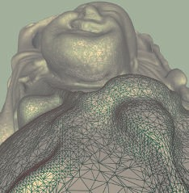 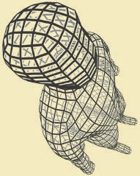

Figure 15.24. Pixel-shader-generated lines. On the left are antialiased single-pixel width edges; on the right are variable thickness lines with haloing. *(Images courtesy of J. Andreas Bærentzen.)*

held constant. See Figure 15.24. The main drawback is that contour edges are drawn half as thick as interior lines, since each triangle draws half of each line’s thickness. In practice this mismatch is often not noticeable.

This idea is extended and simplified by Celes and Abraham [242], who also give a thorough summary of previous work. Their idea is to use a one-dimensional set of texture coordinates for each triangle edge, 1*.*0 for the two vertices defining the edge and 0*.*0 for the other vertex. They exploit texture mapping and the mip chain to give a constant-width edge. This approach is easy to code and provides some useful controls. For example, a maximum density can be set so that dense meshes do not become entirely filled with edges and so become a solid color.

## Rendering Obscured Lines

In normal wireframe drawing, where no surfaces are drawn, all edges of a model are visible. To avoid drawing the lines that are hidden by surfaces, draw all the filled triangles into just the *z*-buffer, then draw the edges normally [1192]. If you cannot draw all surfaces before drawing all lines, a slightly more costly solution is to draw the surfaces with a solid color that matches the background.

Lines can also be drawn as partially obscured instead of fully hidden. For example, hidden lines could appear in light gray instead of not being drawn at all. This can be done by setting the *z*-buffer’s state appropriately. Draw as before, then reverse the sense of the *z*-buffer, so that only lines that are *beyond* the current pixel’s *z*-depth are drawn. Also turn off *z*-buffer modification, so that these drawn lines do not change any depth values. Draw the lines again in the obscured style. Only lines that would

Figure 15.25. Four line rendering styles. From left to right: wireframe, hidden line, obscured line, and haloed line.

be hidden are then drawn. For stylized versions of lines, a full hidden-line-removal process can be used [282].

## Haloing

When two lines cross, a common convention is to erase a part of the more distant line, making the ordering obvious. This can be accomplished relatively easily by drawing each line twice, once with a halo [1192]. This method erases the overlap by drawing over it in the background color. First, draw all the lines to the *z*-buffer, representing each line as a thick quadrilateral that represents the halo. A geometry shader can help with creating such quadrilaterals. Then, draw every line normally in color. The areas masked off by the *z*-buffer draws will hide lines drawn behind them. A bias or other method has to be used to ensure that each thin black line lies atop the thick *z*-buffer quadrilateral.

Lines meeting at a vertex can become partially hidden by the competing halos. Shortening the quadrilaterals creating the halos can help, but can lead to other ar- tifacts. The line rendering technique from Bærentzen et al. [86, 1295] can also be used for haloing. See Figure 15.24. The halos are generated per triangle, so there are no interference problems. Another approach is to use image post-processing (Sec- tion 15.2.3) to detect and draw the halos.

Figure 15.25 shows results for some of the different line rendering methods dis- cussed here.

# Text Rendering

Given how critical reading text is to civilization, it is unsurprising that considerable attention has been lavished on rendering it well. Unlike many other objects, a single pixel change can make a significant difference, such as turning an “l” into a “1.” This section summarizes the major algorithmic approaches used for text rendering.

The eye is more sensitive to differences in intensity than to those in color. This fact has been used since at least the days of the Apple II [527] to improve perceived spatial resolution. One application of this idea is Microsoft’s ClearType technology,

 

Figure 15.26. Magniﬁed grayscale antialiased and subpixel antialiased versions of the same word. When a colored pixel is displayed on an LCD screen, the corresponding colored vertical subpixel rectangles making up the pixel are lit. Doing so provides additional horizontal spatial resolution. *(Images generated by Steve Gibson’s “Free & Clear” program.)*

which is built upon one of the characteristics of *liquid-crystal display* (LCD) displays. Each pixel on an LCD display consists of three vertical colored rectangles, red, green, and blue—use a magnifying glass on an LCD monitor and see for yourself. Disregard- ing the colors of these subpixel rectangles, this configuration provides three times as much horizontal resolution as there are pixels. Using different shades fills in different subpixels, and so this technique is sometimes called *subpixel rendering*. The eye blends these colors together, and the reddish and blue fringes become undetectable. See Fig- ure 15.26. This technology was first announced in 1998 and was a great help on large, low-DPI LCD monitors. Microsoft stopped using ClearType in Word 2013, evidently because of problems from blending text with different background colors. Excel uses the technology, as do various web browsers, along with Adobe’s CoolType, Apple’s Quartz 2D, and libraries such as FreeType and SubLCD. An old yet thorough article by Shemanarev [1618] covers the various subtleties and issues with this approach.

This technique is a sterling example of how much effort is spent on rendering text clearly. Characters in a font, called *glyphs*, typically are described by a series of line segments and quadratic or cubic B´ezier curves. See Figure 17.9 on page 726 for an example. All font rendering systems work to determine how a glyph affects the pixels it overlaps. Libraries such as FreeType and Anti-Grain Geometry work by generating a small texture for each glyph and reusing them as needed. Different textures are made for each font size and *emphasis*, i.e., italics or bold.

These systems assume that each texture is pixel-aligned, one texel per pixel, as it normally is for documents. When text is applied to three-dimensional surfaces, these assumptions may no longer hold. Using a texture with a set of glyphs is a simple and popular approach, but there are some potential drawbacks. The application may still align text to face the viewer, but scaling and rotation will break the assumption of a single texel per pixel. Even if screen-aligned, *font hinting* may not be taken into account. Hinting is the process of adjusting the glyph’s outline to match up with the pixel cells. For example, the vertical stem of an “I” that is a texel wide is best rendered covering a single column of pixels instead of half-covering two adjacent columns. See Figure 15.27. All these factors mean a raster texture can display blurriness or aliasing problems. Rougier [1515] gives thorough coverage of the issues involved with texture- generation algorithms and shows how FreeType’s hinting can be used in an OpenGL- based glyph-rendering system.

The Pathfinder library [1834] is a recent effort that uses the GPU to generate glyphs. It has a low setup time and minimal memory use, and outperforms competing

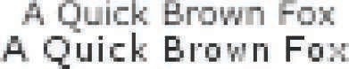

Figure 15.27. The Verdana font rendered unhinted (top) and hinted (bottom). *(Image courtesy of Nicolas Rougier [1**515**].)*

CPU-based engines. It uses tessellation and compute shaders to generate and sum up the effects of curves on each pixel, with fallbacks to geometry shaders and OpenCL on less-capable GPUs. Like FreeType, these glyphs are cached and reused. Its high- quality antialiasing, combined with the use of high-density displays, makes hinting nearly obsolete.

Applying text to arbitrary surfaces at different sizes and orientations can be done without elaborate GPU support, while still providing reasonable antialiasing. Green [580] presents such a system, first used by Valve in *Team Fortress 2*. The algo- rithm uses the *sampled distance field* data structure introduced by Frisken et al. [495]. Each texel holds the signed distance to the nearest edge of a glyph. A distance field attempts to encode the exact bounds of each glyph in a texture description. Bilinear interpolation then gives a good approximation of the alpha coverage of the letter at each sample. See Figure 15.28 for an example. Sharp corners may become smoothed by bilinear interpolation, but can be preserved by encoding more distance values in four separate channels [263]. A limitation of this method is that these signed distance textures are time consuming to create, so they need to be precomputed and stored. Nonetheless, several font rendering libraries are based on this technique [1440], and it adapts well to mobile devices [3]. Reshetov and Luebke [1485] summarize work along these lines and give their own scheme, based on adjusting texture coordinates for samples during magnification.

Even without scaling and rotation concerns, fonts for languages using Chinese characters, for example, may need thousands or more glyphs. A high-quality large character would require a larger texture. Anisotropic filtering of the texture may be needed if the glyph is viewed at an angle. Rendering the glyph directly from its edge and curve description would avoid the need for arbitrarily large textures and avoid the artifacts that come from sampling grids. The Loop-Blinn method [1068, 1069] uses a pixel shader to directly evaluate B´ezier curves, and is discussed in Section 17.1.2. This technique requires a tessellation step, which can be expensive when done at load time. Dobbie [360] avoids the issue by drawing a rectangle for the bounding box of each character and evaluating all the glyph outlines in a single pass. Lengyel [1028] presents a robust evaluator for whether a point is inside a glyph, which is critical to avoid artifacts, and discusses evaluation optimizations and effects such as glows, drop shadows, and multiple colors (e.g., for emojis).

 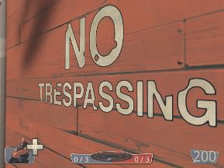

Figure 15.28. Vector textures. On the left, the letter “g” shown in its distance ﬁeld representation [3]. On the right, the “no trespassing” sign is rendered from distance ﬁelds. The outline around the text is added by mapping a particular distance range to the outline color [580]. *(Image on left courtesy of ARM Ltd. Image on right from “Team Fortress 2,” courtesy of Valve Corp.)*

## Further Reading and Resources

For inspiration about non-photorealistic and toon rendering, read Scott McCloud’s *Understanding Comics* [1157]. For a view from a researcher’s perspective, see Hertz- mann’s article [728] on using NPR techniques to help build scientific theories about art and illustration.

The book *Advanced Graphics Programming Using OpenGL* [1192], despite being written during the era of fixed-function hardware, has worthwhile chapters on a wide range of technical illustration and scientific visualization techniques. Though also somewhat dated, the books by the Gooches [563] and by Strothotte [1719] are good starting places for NPR algorithms. Surveys of contour edge and stroke rendering tech- niques are provided by Isenberg et al. [799] and Hertzmann [727]. The lectures from the SIGGRAPH 2008 course by Rusinkiewicz et al. [1521] also examine stroke ren- dering in detail, including newer work, and B´enard et al. [130] survey frame-to-frame coherence algorithms. For artistic image-processing effects, we refer the interested reader to the overview by Kyprianidis et al. [949]. The proceedings of the *Interna- tional Symposium on Non-Photorealistic Animation and Rendering* (NPAR) focus on research in the field.

Mitchell et al. [1223] provide a case study about how engineers and artists col- laborated to give a distinctive graphic style to the game *Team Fortress 2*. Shodhan and Willmott [1632] discuss the post-processing system in the game *Spore* and in- clude pixel shaders for oil paint, old film, and other effects. The SIGGRAPH 2010 course “Stylized Rendering in Games” is another worthwhile source for practical ex- amples. In particular, Thibault and Cavanaugh [1761] show the evolution of the art

style for *Borderlands* and describe the technical challenges along the way. Evans’ pre- sentation [446] is a fascinating exploration of a wide range of rendering and modeling techniques to achieve a particular media style.

Pranckeviˇcius [1440] provides a survey of accelerated text rendering techniques filled with links to resources.